**ASSIGNMENT:1(MODULE 1)**

**1>What is SDLC?**

* SDLC stands for software development life cycle
* SDLC is a structure imposed on the development of a software product that defines the process for planning, implementation, testing, documentation, deployment, and ongoing maintenance and support.

**2> What is software testing?**

* Testing is the process of evaluating a system or its component(s) with the intent to find that whether it satisfies the specified requirements or not.
* Software Testing is a process used to identify the correctness, completeness, and quality of developed computer software.

**3> What is agile methodology?**

* The Agile methodology is a project management approach that involves breaking the project into phases and emphasizes continuous collaboration and improvement.

**4> What is SRS**

* SRS is stands for Software Requirement Specification.
* A software requirements specification (SRS) is a complete description of the behavior of the system to be developed.
* It includes a set of use cases that describe all of the interactions that the users will have with the software

**5> What is oops**

* OOP is an object-oriented programming technique that combines data and instructions for processing that data into an object that can be used within the program.

**6> Write Basic Concepts of oops**

* Class
* Objects
* Data Abstraction
* Encapsulation
* Inheritance
* Polymorphism
* Dynamic Binding
* Message Passing

**7>what is object**

* It is a basic unit of Object-Oriented Programming and represents the real-life entities
* An Object is an instance of a Class.
* An object represents an individual, identifiable item, unit, or entity, either real or abstract, with a well- defined role in the problem domain.

**8> What is class**

* Class: An object is a particular instance of a class which has actual existence and there can be many objects (or instances) for a class.
* When you define a class, you define a blueprint for an object.

**9> What is encapsulation**

* Encapsulation: Encapsulation is the practice of including in an object everything it needs hidden from other objects. The internal state is usually not accessible by other objects.
* Encapsulation in Java is the process of wrapping up of data (properties) and behavior (methods) of an object into a single unit; and the unit here is a Class (or interface).

**10> What is inheritance**

* Inheritance: Inheritance means that one class inherits the characteristics of another class. This is also called a “is a” relationship.

**11> • What is polymorphism**

* Polymorphism: Polymorphism means “having many forms”
* Poly refers to many. That is a single function or an operator functioning in many ways different upon the usage is called polymorphism

**12> Draw Usecase on Online book shopping.**

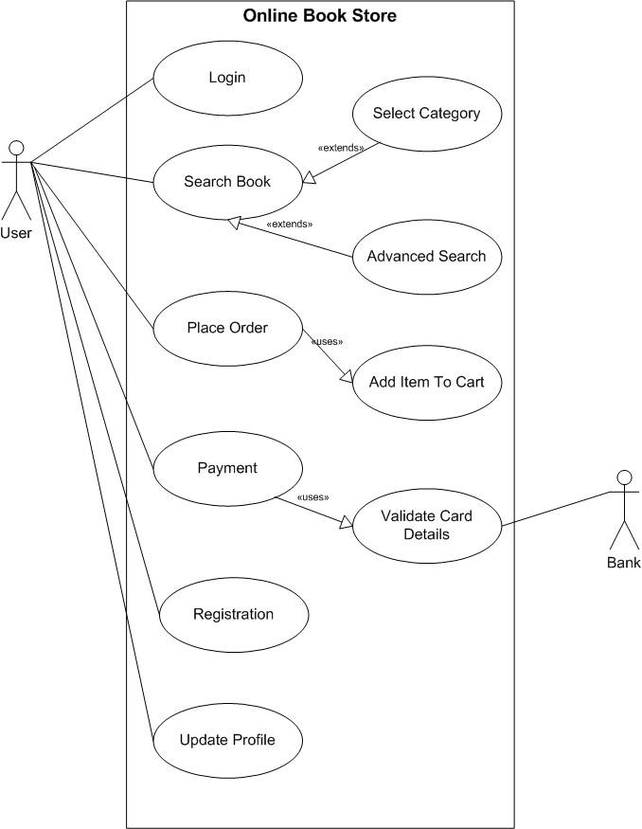

**13> Draw Usecase on online bill payment system (paytm)**

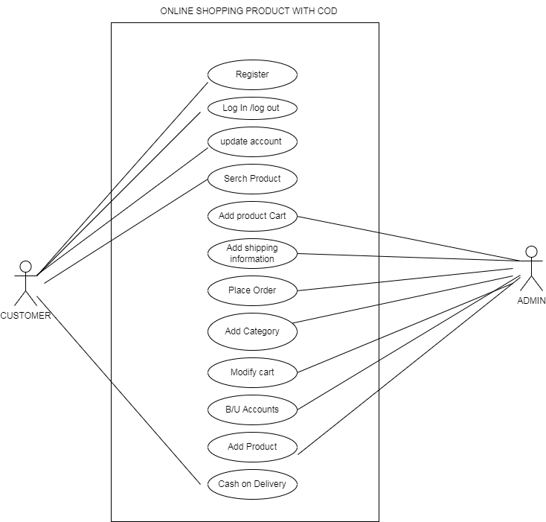

**14> Write SDLC phases with basic introduction**

|  |  |
| --- | --- |
| Requirements Collection/Gathering | Establish Customer Needs |
| Analysis | Model And Specify the requirements- “What” |
| Design | Model And Specify a Solution – “Why” |
| Implementation | Construct a Solution In Software |
| Testing | Validate the solution against the requirements |
| Maintenance | Repair defects and adapt the solution to the new requirements |

**15> Explain Phases of the waterfall model**

* Requirements: All possible requirements of the system to be developed are captured in this phase and documented in a requirement specification document.
* Analysis:
* Design:
* Implementation
* Testing
* Maintenace

**16> Write phases of spiral model**

* Determine objectives and find alternate solution
* Risk Analysis and Resolving
* Develop test
* Review and Planning of the next phase

**17> Write agile manifesto principles**

* satisfy customers
* changing requirements
* Frequent Delivery
* Communicate regularly
* support team members
* Face to face communication
* Measure work progress
* Devlopment process
* Good design
* Measure progress
* Continue seeking result
* Reflect and adjust regularly

**18> Explain working methodology of agile model** **and also write pros and cons.**

* Agile Methods break the product into small incremental builds.
* These builds are provided in iterations.
* Each iteration typically lasts from about one to three weeks.
* Every iteration involves cross functional teams working simultaneously on various areas like planning, requirements analysis, design, coding, unit testing, and acceptance testing.
* At the end of the iteration a working product is displayed to the customer and important stakeholders.

**Agile pros:**

* Is a very realistic approach to software development
* Promotes teamwork and cross training.
* Functionality can be developed rapidly and demonstrated.
* Resource requirements are minimum.
* Suitable for fixed or changing requirements Delivers early partial working solutions.
* Good model for environments that change steadily. Minimal rules, documentation easily employed.
* Enables concurrent development and delivery within an overall planned context.
* Little or no planning required Easy to manage Gives flexibility to developers

**Agile cons:**

* Not suitable for handling complex dependencies.
* More risk of sustainability, maintainability and extensibility.
* An overall plan, an agile leader and agile PM practice is a must without which it will not work.
* Strict delivery management dictates the scope, functionality to be delivered, and adjustments to meet the deadlines.
* Depends heavily on customer interaction, so if customer is not clear, team can be driven in the wrong direction.
* There is very high individual dependency, since there is minimum documentation generated.
* Transfer of technology to new team members may be quite challenging due to lack of documentation.

**19> Draw usecase on Online shopping product using COD.**

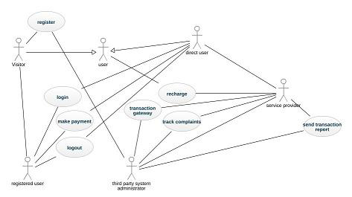

**20> Draw usecase on Online shopping product using payment gateway.**

